For my final project I decided to make the game hangman with Verilog code. I chose the word DIGITAL for the game. The majority of my project was figuring out how to use the LCD 1602A screen. Originally, I came across a few sources of how to operate the LCD with an Arduino then modified the pin layout for the Terasic DE10-Lite. VSS and BLK were plugged into ground and VDD was plugged directly into 5V. BLA was plugged into 5V through a 220 Ω resistor. Vo was connected to a potentiometer. This allows the screen's brightness to be adjusted. The read/write pin was wired directly to ground to permanently set it to write as read was not necessary in the scope of this project. Enable, RS, and the data pins 0-7 were connected to GPIO pins 35-26 respectively. This allowed me send in the instruction codes without having to reverse them.

After finding the correct data sheet and reading over it, I learned that the system works by taking in a 9-bit instruction signal (RS and the data pins) that tells the device what to do. The enable pin then is toggled on and off to activate the code instructions. I initially tested what each instruction did by applying each pin to a switch on the board. I wasn't able to fully figure out how to use 4 pin mode, so I switched to 8 pin mode, and I was able to get the device to work properly. The instructions I used in the project were turning on the screen and cursor, setting it to two row screen mode, clearing screen, setting cursor location, and writing preset characters.

The idea behind the code for hangman was very simple. The setup instruction codes would be transmitted to the LCD and then the system would wait for a letter to be input. In my original plan I hoped to get to a point where I could add a UART to connect it to a computer keyboard. However, I was not able to get to this stage. To simulate UART, I implemented a module that would take in the ascii value from switches 7-0 and send it when switch 8 was turned on. Then the ascii value would go through a module that turned it into the LCD instruction code for that letter. A state machine would be activated that would check the letter and move to the corresponding state. Each state transmits the code to set the cursor position to the location in the word. If the letter was not in the word, it would move to the Hangman state that sets the cursor to a location variable that is then incremented by 1. Next the state would move to a Set Letter state that would write the selected letter to the LCD. For the repeating “I” I added a state that wrote the letter and then moved to the next location before moving to the Set Letter state. If the wrong letter position reached 7 it would move to a Game Over state.
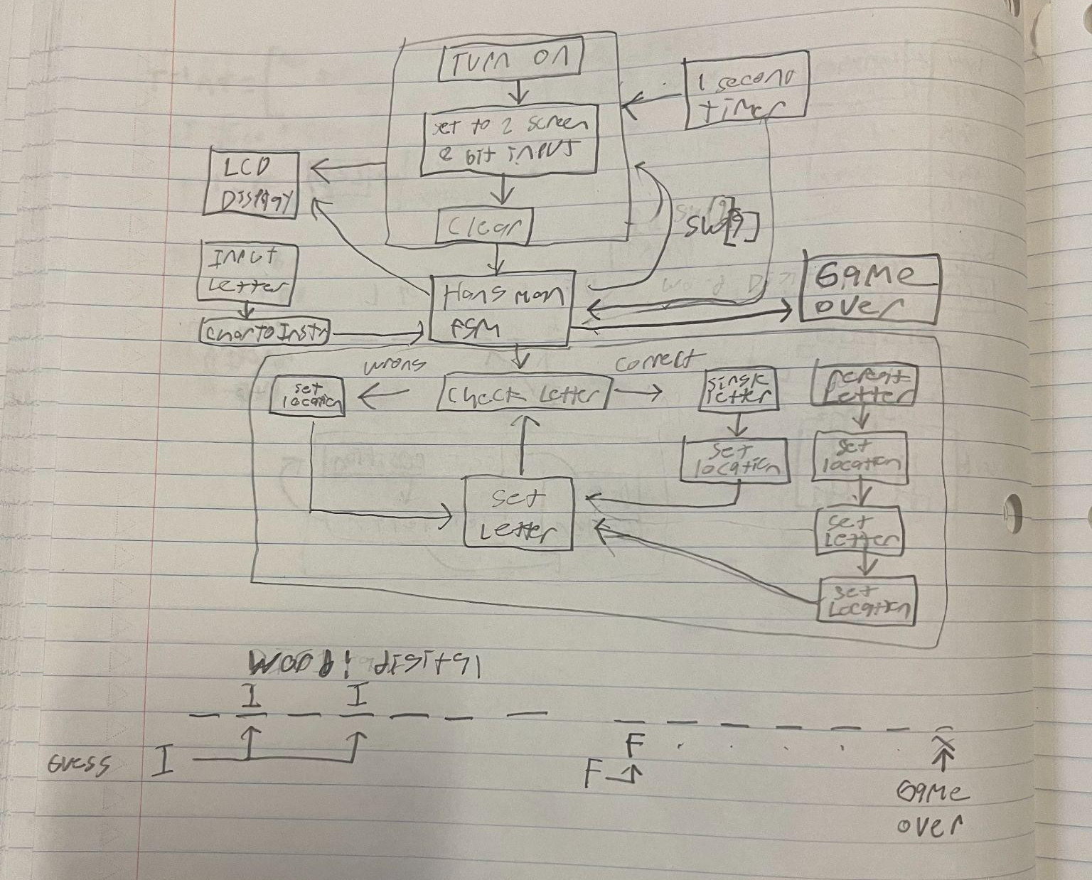

The biggest problem I ran into while doing this project was that there was a glitch causing the code to only work properly with “I” as an input. I was not able to locate the cause of this glitch before I ran out of time before the presentations. However, while I was looking over the code, I noticed that the instruction code for the letter “D” in the char2Instr module was missing a 0. This could have been sending the wrong instruction code to the LCD or cause no signal to be transmitted at all leading to the malfunction.

Another problem I ran into early on was that I couldn't figure out how to get the instructions to be registered during state changes. Online, I found some code that toggles on and off a variable in between state changes. This code allowed me to automate the enable pin between states that switched the instruction code. This allowed the LCD to register each code.

Another problem I solved was automating the state changes. To fix this I used a 1 second timer module and set the states to change on alternating values of the tick variable. This way it would move through states every second.
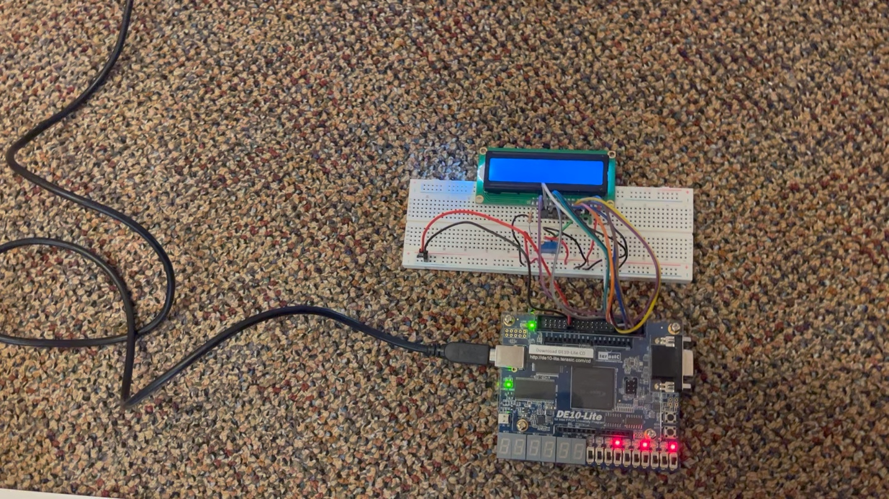
Video that shows LCD turning on and I state being used:

